P6.1 The interface for the Complex class is provided below (Note that the first letter of Complex is capitalized in order to distinguish it from the complex class defined in <complex> header file). A complex number c is defined as c = a + bi where c is the complex number consisting of two part: real part denoted by ‘a’ and an imaginary part denoted by ‘b’ multiplied by i and i = $\sqrt{-1}$. (The website at https://en.wikipedia.org/wiki/Complex_number provides an introductory level discussion of complex numbers.) Operations such as addition, subtraction, multiplication, and division can be performed on complex number in a way similar to the operations performed on rational numbers since computations only involve a and b, which are real numbers. For you convenience, the basic four operations or computations are provided below. Note that all four computations involve only real numbers (double type in C++), this program is very similar to the rational number problem.

Addition:

Subtraction:

Multiplication:

Division: 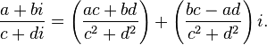

where i = $\sqrt{-1}$ ; it does not even enter into your program code.

class Complex
{
friend ostream& operator<<(ostream &out, const Complex &cobj);
// Postcondition: contents of cobj is display in (a, b) format, e.g., 3 - 4i ==> (3, -4)

friend istream& operator>>(istream &out, Complex &cobj);
// prompt message "Enter real and imaginary values: " is displayed in main() by the client of the class
// Postconodition: two values entered by the users are assinged to real and imag of cobj, respectively
public:
Complex();
// default constructor

Complex(double r, double i);
// Postcondition: a complex object is declared and initialized to (r, i) or (0, 0) if no values are passed to the constructor

void setComplexNumber(double a, double b);
// a mutator function
// Postcondition: set the real and imaginary parts of the calling complex object to a and b, respectively

Complex operator+(const Complex &c2) const;
// Postcondition: sum of (*this) - c2 is returned

Complex operator-(const Complex &c2) const;
// Postcondition: difference of (*this) - c2 is returned

Complex operator*(const Complex &c2) const;
// Postcondition: product of (*this) * c2 is returned

Complex operator/(const Complex &c2) const;
// Postcondition: quotient of (*this) / c2 is returned

bool operator==(const Complex &c2) const;
// Postcondition: returns true if (*this == c2) is true; returns false otherwise

private:
double real; // real part of a complex number (a, b)
double imag; // imaginary part of a complex number (a, b)
};
- You are asked to implement all the member and non-member functions.
- Write a main() function to test all the above functions. The output should be similar to the following sample display:

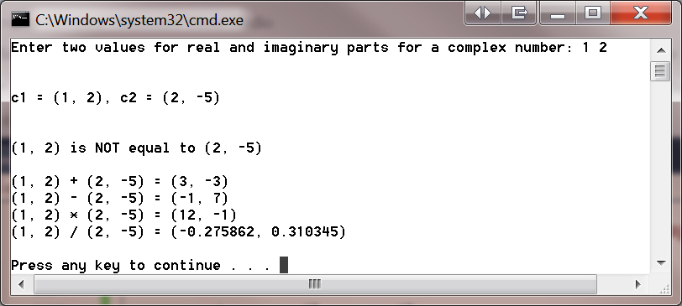

P6.2 (Optional) The interface for the String class (notice that the first letter of String in capitalized to distinguish it from the “string” class defined by C++ in <string> header file) is provide below.

class String
{
friend ostream &operator<<(ostream &, const String &obj);
// Postcondition: output/display sobj

friend istream &operator>>(istream &, String &sobj);
// Client of this function prompts the user to enter a string
// Postcondition: input values from the user to initialize sobj
public:
String(const char* = "");
// Default constructor

String(const String &sobj);
// copy constructor
// Postcondition: newly created object is initialized with values from sobj

~String();
// destructor

const String &operator=(const String &sobj);
// Postcondition: calling object gets the values of sobj

const String &operator+=(const String &sobj);
// Postcondition: sum/concatenation of the calling object and sobj is returned

bool operator==(const String &sobj) const;
// Postcondition: return true if calling object == sobj; return false otherwise

bool operator<(const String &) const;
// Postcondition: return true if calling object < sobj; return false otherwise

bool operator>(const String &) const;
// Postcondition: return true if calling object > sobj; return false otherwise

char operator[](int) const;
// Postcondition: return true if calling object < sobj; return false otherwise

int getLength() const;
// Postcondition: return true if calling object < sobj; return false otherwise

private:
int length;
char *sPtr; // points to a dynamic C-string, which is a null-terminated char array
};

You are asked to
- Implement all member and friend functions
- Write a main() function to test all those functions. You are asked to format the outputs to make it easy to read.

- Note: To carry out this assignment, you may need to use some of the C-string manipulation functions such as strcpy, strcat, strcmp, etc. You may want to visit http://www.cplusplus.com/reference/cstring/ for more detailed information.

